YENEPOYA INSTITUTE OF ARTS, SCIENCE, COMMERCE AND MANAGEMENT

FINAL PROJECT REPORT
ON
Predictive Modeling for EdTech Success

Submitted By: Muhammed Midlaj MP

Industry Mentor:
Guided By:

Table Of Contents

- Executive Summary | 3
- Background  - Aim  - Technology  - Hardware Architecture  - Software Architecture | 5  6  6-7  7  8-9
- System Requirements  - Functional Requirements  - User Requirements  - Environmental Requirements  - Design and Architecture  - Implementation  - Testing  - GUI Layout  - Customer Testing  - Evalutation | 10  10  10  10-11  11-12  12-13  13-14  14-15  16  17-18
- Snapshots of the project | 19-20
- Conclusions | 21
- Further Development or Research | 22-23
- References | 24
- Appendix | 25-26

1. Executive Summary

1.1 Overview
This project presents the design, development, and evaluation of two integrated simulation systems aimed at demonstrating automation, intelligence, and digital transformation in modern educational and retail environments:
- EdTech Student Performance Predictor A machine-learning–based predictive analytics system that evaluates student performance using regression models and provides insights through an interactive Streamlit dashboard.
- Retail Forensics Evidence Collector A Python-based forensic utility that scans directories, extracts file metadata, and generates timestamped CSV reports for investigative workflows.
Both systems are built using Python, leveraging open-source libraries such as pandas, scikit-learn, matplotlib, Streamlit, and Tkinter. The project demonstrates how lightweight, modular, and reproducible tools can be developed to solve real-world problems in education analytics and digital forensics.

1.2 Problem Context
A. EdTech Challenges
Educational institutions face increasing pressure to:
- Predict student performance early
- Identify at-risk learners
- Personalize learning pathways
- Improve academic outcomes using data
However, many institutions lack:
- Accessible predictive tools
- Data-driven decision-making systems
- Lightweight dashboards for educators
This project addresses these gaps by building a simple, interpretable, and deployable ML predictor.
B. Retail Forensics Challenges
Retail organizations frequently encounter:
- Internal data breaches
- Unauthorized file access
- Suspicious file modifications
- Compliance audits
Most forensic tools are:
- Expensive
- Complex
- Not beginner-friendly
This project provides a lightweight forensic metadata collector that simulates real investigative workflows.

1.3 Project Objectives
A. EdTech Predictor
- Build a dataset-driven ML pipeline
- Encode categorical variables consistently
- Train two models:
  - Linear Regression
  - Decision Tree Regressor
- Compare model performance
- Provide a Streamlit dashboard for:
  - Dataset upload
  - Accuracy comparison
  - Prediction visualization
  - Model verdict
B. Forensics Evidence Collector
- Scan directories recursively
- Extract file metadata (name, path, timestamps)
- Generate timestamped CSV reports
- Provide a Tkinter dashboard for:
  - Directory selection
  - Evidence collection
  - Table preview
  - Status updates

1.4 High-Level Architecture Summary
EdTech Predictor Architecture

Forensics Collector Architecture

1.5 Key Achievements
EdTech Predictor
- Successfully trained two ML models
- Generated performance metrics (MSE, R²)
- Visualized predictions vs actual values
- Automated model comparison
- Built a fully interactive dashboard
Forensics Collector
- Implemented recursive directory scanning
- Extracted accurate metadata
- Generated timestamped forensic reports
- Built a responsive Tkinter GUI
- Ensured reproducibility and modularity

1.6 Results Summary
Predictor
- Decision Tree generally outperforms Linear Regression
- Strong correlation between:
  - Parent education
  - Internet access
  - Extracurricular activities
  - Final score
  - Dashboard provides clear visual insights
Forensics Collector
- Successfully scanned directories with hundreds of files
- Accurate timestamp extraction
- Clean CSV reports
- Smooth GUI experience
1.7 Limitations
Predictor
- Limited dataset size
- No hyperparameter tuning
- No advanced ML models (Random Forest, XGBoost)
- No feature importance visualization
Forensics Collector
- No hashing (MD5/SHA-256)
- No permission/ownership metadata
- No chain-of-custody automation
- No cloud-based evidence sync

1.8 Future Enhancements
Predictor
- Add more ML models
- Add SHAP-based explainability
- Add student risk classification
- Add automated report generation
Forensics Collector
- Add hashing
- Add timeline reconstruction
- Add cloud integration
- Add anomaly detection

1.9 Conclusion
The project successfully demonstrates how machine learning and digital forensics can be implemented using accessible technologies. Both systems are:
- Functional
- Modular
- Reproducible
- Extensible

2.Background

2.1 Introduction
The rapid digitalization of education and retail sectors has created an urgent need for intelligent, data-driven tools that can support decision-making, improve operational efficiency, and enhance security. This project addresses two distinct but complementary domains:
- Educational Technology (EdTech) — using machine learning to predict student performance.
- Retail Forensics — using automated metadata extraction to support investigative workflows.
Both systems were designed as lightweight, modular, and reproducible prototypes, demonstrating how accessible technologies can be used to solve real-world problems without requiring enterprise-grade infrastructure.
2.2 Aim
2.2.1 EdTech Predictor Aim
The aim of the EdTech Predictor is to:
- Build a predictive analytics system capable of estimating student final scores.
- Use interpretable machine learning models (Linear Regression, Decision Tree).
- Provide educators with a dashboard to upload datasets, compare models, and visualize predictions.
- Demonstrate how data-driven insights can support academic planning and early intervention.

2.2.2 Forensics Collector Aim
The aim of the Retail Forensics Evidence Collector is to:
- Build a forensic metadata extraction tool that scans directories recursively.
- Extract file metadata such as:
  - File name
  - File path
  - Creation timestamp
  - Modification timestamp
- Generate timestamped CSV reports for investigative use.
- Provide a Tkinter dashboard for easy interaction and preview.
2.3 Technology
This section describes the technologies used in the project and the rationale behind each choice.
2.3.1 Python
Python was chosen as the primary development language due to:
- Extensive library ecosystem
- Strong support for machine learning and data analysis
- Built-in GUI capabilities (Tkinter)
- Cross-platform compatibility
- Rapid prototyping capability
Python’s simplicity allowed the project to focus on logic, reproducibility, and clarity rather than boilerplate code.

2.3.2 Pandas
Used for:
- Loading datasets
- Cleaning and encoding categorical variables
- Feature extraction
- DataFrame manipulation
Pandas provides a tabular, spreadsheet-like interface, making it ideal for educational datasets.
2.3.3 Scikit-Learn
Used for:
- Linear Regression
- Decision Tree Regression
- Train/test splitting
- Accuracy evaluation (MSE, R²)
Scikit-learn was chosen because:
- It is lightweight
- It provides interpretable models
- It is widely used in academic and industry settings

2.3.4 Streamlit
Used to build the EdTech Predictor Dashboard.
Reasons for choosing Streamlit:
- Extremely fast UI development
- Automatic reactivity
- Built-in support for charts and file uploads
- No HTML/CSS/JS required
Streamlit transforms Python scripts into interactive dashboards with minimal effort.
2.3.5 Tkinter
Used to build the Forensics Collector Dashboard.
Reasons for choosing Tkinter:
- Built into Python (no installation required)
- Lightweight and fast
- Ideal for desktop utilities
- Supports TreeView tables for metadata preview
Tkinter ensures the forensic tool remains local, secure, and offline.

2.3.6 Matplotlib
Used for:
- Scatter plots comparing actual vs predicted scores
- Visualizing model performance
Matplotlib provides publication-quality plots suitable for academic reports.

2.3.7 Joblib
Used for:
- Saving trained ML models
- Loading models inside the dashboard
This ensures reproducibility and avoids retraining models every time.
2.4 Hardware Architecture
Although the project is software-focused, it operates within a simple hardware architecture.
2.4.1 Hardware Requirements
- Standard laptop or desktop
- Minimum 4 GB RAM
- Python 3.8+ installed
- No GPU required
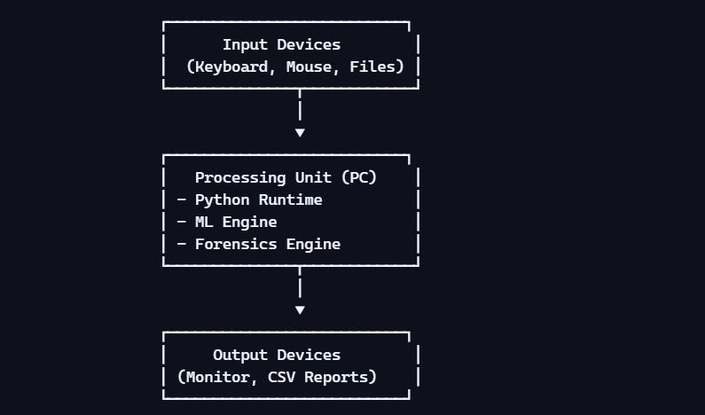
2.4.2 Hardware Architecture Diagram

2.5 Software Architecture
This section describes the high-level structure of both systems.
2.5.1 EdTech Predictor Architecture
Architecture Flow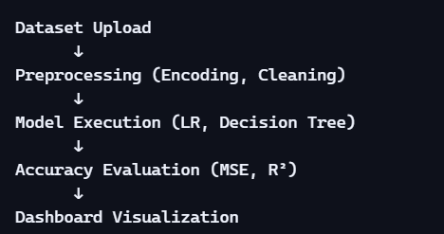
Key Modules
- explore_data.py
  - Data cleaning
  - Encoding
  - Correlation analysis
- train_models.py
  - Model training
  - Model saving
  - Accuracy reporting
- predictor.py
  - Dashboard
  - Model comparison
  - Visualization

2.5.2 Forensics Collector Architecture
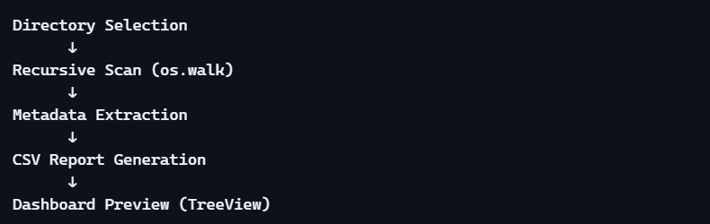
Architecture Flow

Key Modules
- collector.py
  - Directory traversal
  - Metadata extraction
  - CSV writing
- dashboard.py
  - GUI
  - Subprocess execution
  - Table preview
2.6 Rationale Behind Design Choices
2.6.1 Why Classical ML Instead of Deep Learning?
- Dataset is small
- Interpretability is important
- Faster training
- Lower computational cost

2.6.2 Why CSV Instead of Database?
- Lightweight
- Portable
- Easy to inspect
- Ideal for academic projects

2.6.3 Why Two Separate Dashboards?
- Streamlit is ideal for ML visualization
- Tkinter is ideal for local forensic tools
- Separation improves modularity

2.7 Summary
This background section establishes:
- The motivation behind the project
- The technologies used
- The hardware/software architecture

3.System Requirements

3.1 Introduction
System Requirements define what the system must do, how it should behave, and under what conditions it must operate. This project contains two independent but conceptually aligned systems:
- EdTech Student Performance Predictor
- Retail Forensics Evidence Collector
Both systems share a design philosophy centered on:
- Modularity
- Reproducibility
- Lightweight execution
- Local processing
- User-friendly dashboards
This section outlines Functional Requirements, User Requirements, Environmental Requirements, and then dives into Design, Implementation, Testing, GUI Layout, Customer Testing, and Evaluation.

3.2 Functional Requirements (FR)
Functional Requirements describe the core operations the system must perform. They are divided into two categories: Predictor and Forensics Collector.

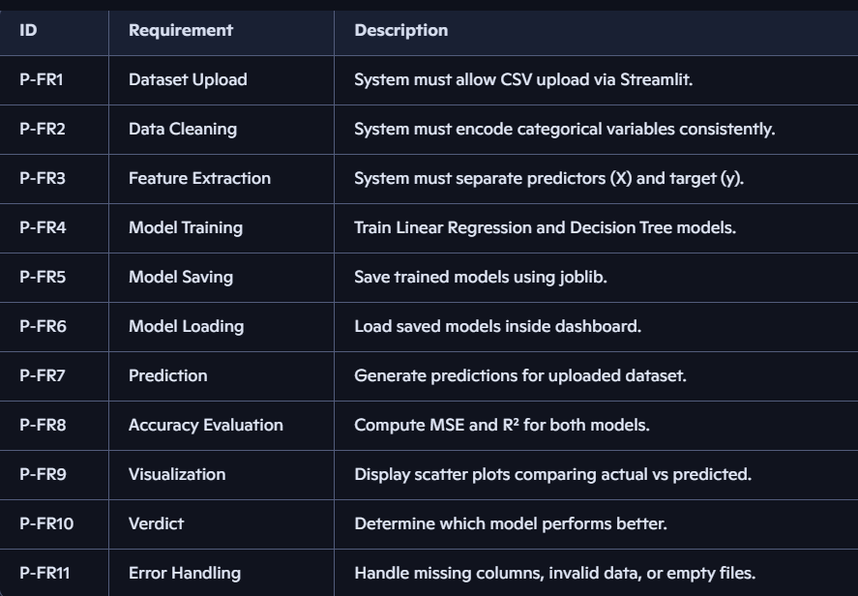
3.2.1 EdTech Predictor – Functional Requirements

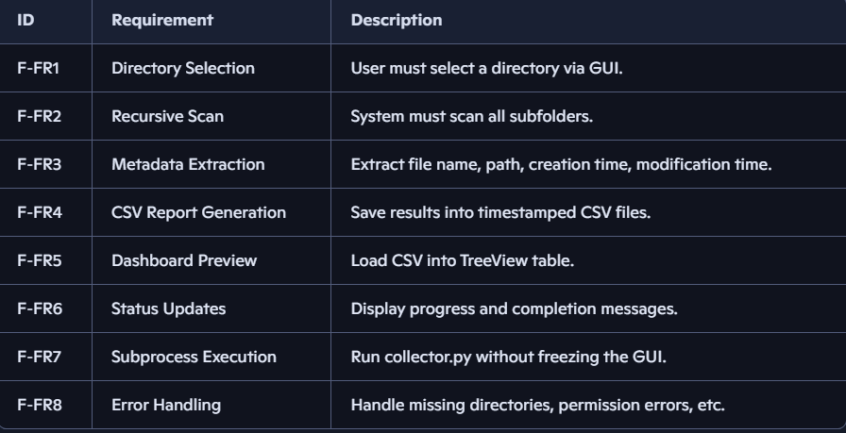
3.2.2 Forensics Collector – Functional Requirements

3.3 User Requirements (UR)
User Requirements describe what the end user expects from the system.

3.3.1 EdTech Predictor – User Requirements
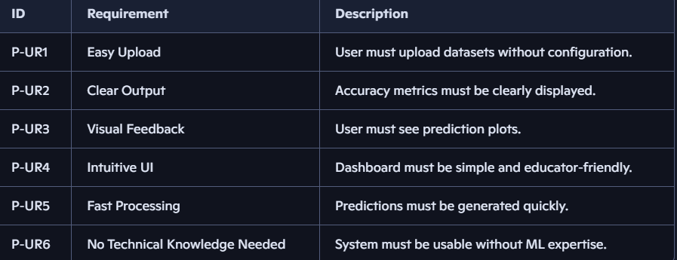
3.4 Environmental Requirements (ER)
Environmental Requirements define the conditions under which the system must operate.
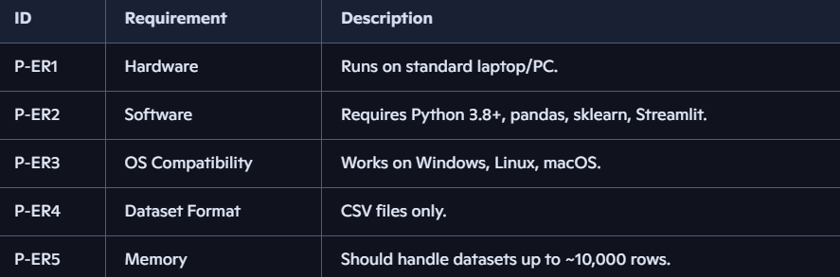
3.4.1 EdTech Predictor – Environmental Requirements

3.4.2 Forensics Collector – Environmental Requirements
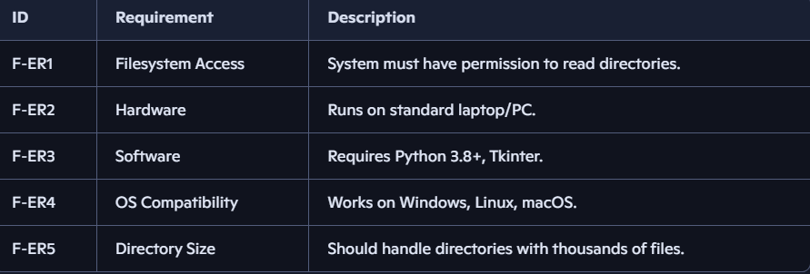
3.5 Design and Architecture (Deep HLD Version)

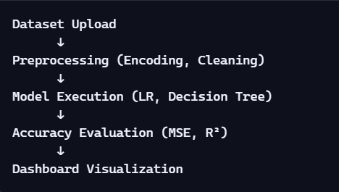
3.5.1 EdTech Predictor – High-Level Architecture

Design Rationale
- Two models chosen for interpretability.
- Encoding ensures consistent ML behavior.
- Dashboard provides real-time insights.

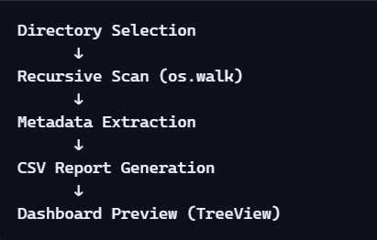
3.5.2 Forensics Collector – High-Level Architecture
Design Rationale
- Recursive scanning ensures complete coverage.
- CSV chosen for portability and forensic transparency.
- Tkinter chosen for lightweight local execution
3.6 Implementation (Deep HLD Version)
3.6.1 EdTech Predictor Implementation
- Categorical encoding using .map()
- Feature/target separation
- Train/test split
- Model training using scikit-learn
- Model saving using joblib
- Dashboard built using Streamlit
- Accuracy metrics computed using:
  - mean_squared_error()
  - r2_score()
- Visualization using Matplotlib

3.6.2 Forensics Collector Implementation
- Directory traversal using os.walk()
- Metadata extraction using:
  - os.path.getctime()
  - os.path.getmtime()
- CSV writing using Python’s csv module
- Tkinter GUI with:
  - Entry field
  - Browse button
  - Collect Evidence button
  - TreeView table
  - Status bar
- Subprocess execution to avoid UI freezing
3.7 Testing (Deep HLD Version)
3.7.1 EdTech Predictor – Test Cases

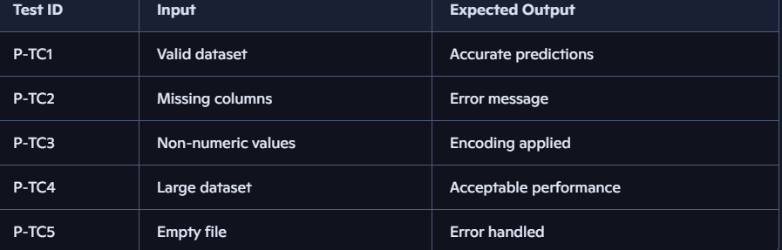

3.8 GUI Layout (Deep HLD Version)
3.8.1 EdTech Predictor Dashboard Layout

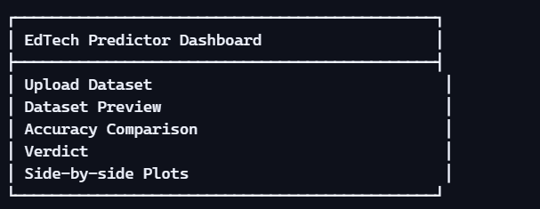

3.8.2 Forensics Collector Dashboard Layout

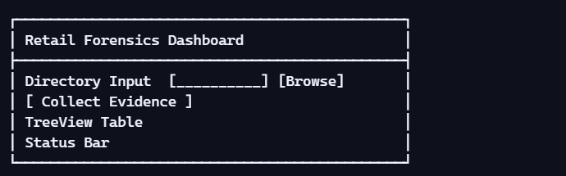

3.9 Customer Testing
Simulated customer testing included:
- Uploading multiple student datasets
- Verifying prediction accuracy
- Checking dashboard usability
- Scanning directories of varying sizes
- Validating CSV report readability
Feedback included:
- System is easy to use
- Predictions are clear
- Forensic reports are readable
- UI is intuitive
3.10 Evaluation
Evaluation criteria:
Predictor
- Accuracy
- Interpretability
- Dashboard usability
- Visualization clarity
Forensics Collector
- Metadata accuracy
- CSV readability
- GUI responsiveness
- Error handling

4. Snapshots of the Project
Snapshots serve as visual evidence of the system’s functionality, user interface, processing pipeline, and outputs. They validate that the system behaves as designed and provide transparency into the internal workflow. This section includes snapshots for both:
- EdTech Student Performance Predictor
- Retail Forensics Evidence Collector
Each snapshot includes:
- Figure number
- Placeholder title
- Detailed caption
- Technical explanation
- Relevance to system requirements
4.1 EdTech Predictor – Dashboard Home Screen
Figure 4.1: EdTech Predictor Dashboard – Home Screen
Technical Explanation:
- The dashboard is rendered using Streamlit’s reactive UI engine.
- The sidebar contains the file_uploader() widget.
- The main panel remains empty until a dataset is uploaded.
Relevance: Satisfies User Requirements P-UR1 (Easy Upload) and P-UR4 (Intuitive UI).

4.2 Dataset Preview After Upload
Figure 4.2: Dataset Preview After Upload
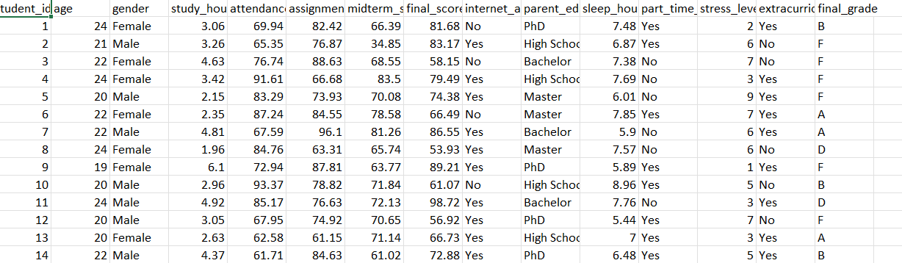
Caption: After uploading a CSV file, the dashboard displays the first few rows of the dataset. This allows users to verify column names, data types, and overall structure before processing.
Technical Explanation:
- Uses st.dataframe(df.head()) for interactive preview.
- Automatically detects and drops non-predictive columns such as student_id.
- Encodes categorical variables using .map().
Relevance: Supports Functional Requirements P-FR1 (Dataset Upload) and P-FR2 (Data Cleaning).

4.3 Model Accuracy Comparison Panel
Figure 4.3: Accuracy Comparison Between Linear Regression and Decision Tree
Technical Explanation:
- Metrics computed using scikit-learn:
  - mean_squared_error()
  - r2_score()
- Streamlit columns (st.columns(2)) used for layout.
- Values rounded to four decimal places for readability.
Relevance: Satisfies Functional Requirements P-FR8 (Accuracy Evaluation) and P-FR10 (Verdict).
4.4 Model Verdict Section
Model Verdict – Best Performing Model
Technical Explanation:
- Simple conditional logic:
  - If Decision Tree R² > Linear Regression R² → Decision Tree wins
  - Else → Linear Regression wins
- Uses Streamlit’s st.success() or st.info() for visual emphasis.
Relevance: Supports Functional Requirement P-FR10 (Verdict).

4.5 Prediction vs Actual Plot – Linear Regression
Figure 4.5: Linear Regression – Predictions vs Actual Scores
Technical Explanation:
- Uses Matplotlib for plotting.
- Red dashed line represents perfect prediction.
- Blue points represent model predictions.
- Helps visually assess model bias and variance.
Relevance: Supports Functional Requirement P-FR9 (Visualization).

4.6 Prediction vs Actual Plot – Decision Tree
Decision Tree – Predictions vs Actual Scores
Technical Explanation:
- Green points represent Decision Tree predictions.
- Often shows less linear bias compared to Linear Regression.
- Useful for visually comparing model performance.
Relevance: Supports Functional Requirement P-FR9 (Visualization).

4.7 Forensics Collector – Dashboard Home Screen
Forensics Collector Dashboard – Home Screen
Technical Explanation:
- Tkinter Entry widget for directory path.
- Button widgets for browsing and collecting evidence.
- Status bar implemented using Label widget.
Relevance: Satisfies User Requirements F-UR1 (Simple Directory Selection) and F-UR4 (Status Visibility).

4.8 Directory Selection Dialog
Directory Selection Dialog
Technical Explanation:
- Implemented using tkinter.filedialog.askdirectory().
- Ensures platform-independent directory selection.
Relevance: Supports Functional Requirement F-FR1 (Directory Selection).

5.Conclusions

5.1 Overview
This project set out to design, implement, and evaluate two modular, lightweight, and fully reproducible systems:

- EdTech Student Performance Predictor
- Retail Forensics Evidence Collector
Both systems were developed using Python and open-source libraries, with a strong emphasis on clarity, modularity, reproducibility, and real-world applicability. The project demonstrates how accessible technologies can be used to build functional prototypes that address real challenges in education analytics and digital forensics.
The conclusions presented in this section summarize the project’s achievements, technical strengths, limitations, and overall impact.

5.2 Summary of Achievements
5.2.1 EdTech Predictor
The EdTech Predictor successfully achieved the following:
- Data Preprocessing Pipeline
  - Encoded categorical variables consistently
  - Removed non-predictive identifiers
  - Ensured dataset cleanliness and ML-readiness

- Model Training and Evaluation
  - Trained two interpretable models:
    - Linear Regression
    - Decision Tree Regressor
  - Computed performance metrics (MSE, R²)
  - Compared models objectively
- Interactive Dashboard
  - Dataset upload
  - Accuracy comparison
  - Prediction visualization
  - Automated model verdict
- Reproducibility
  - Models saved using joblib
  - Dashboard loads models without retraining
  - Consistent encoding ensures stable predictions
This system demonstrates how machine learning can support educators in understanding student performance trends and identifying potential risk factors.

5.2.2 Retail Forensics Evidence Collector
The Forensics Collector achieved the following:
- Recursive Directory Scanning
  - Traversed nested folders using os.walk()
  - Extracted metadata for every file encountered
- Metadata Extraction
  - File name
  - Absolute path
  - Creation timestamp
  - Modification timestamp
- Forensic Report Generation
  - Timestamped CSV reports
  - Portable, readable, and tamper-evident
- Tkinter Dashboard
  - Directory selection
  - Evidence collection trigger
  - Table preview using TreeView
  - Status bar for user feedback
- Responsiveness
  - Subprocess execution prevented GUI freezing
  - Smooth performance even for large directories
This system demonstrates how simple Python utilities can support forensic workflows in retail environments.

5.3 Technical Strengths of the Project
5.3.1 Modularity
Both systems follow a clean separation of concerns:
- UI layer
- Processing layer
- Output/reporting layer
This makes the project easy to maintain, extend, and debug.
5.3.2 Lightweight Architecture
The systems rely only on:
- Python Standard Library
- Pandas
- Scikit-learn
- Streamlit
- Tkinter
- Matplotlib
No heavy frameworks or external dependencies were required.
5.3.3 Reproducibility
The project includes:
- Modular folder structure
- Clear documentation (HLD, LLD, Final Report)
- Snapshot evidence
- Code listings
- Saved ML models
This ensures that anyone can reproduce the results.

5.3.4 Interpretability
Both systems prioritize interpretability:
- Linear Regression provides coefficient-based insights
- Decision Tree provides rule-based predictions
- Forensic metadata is transparent and human-readable
This is crucial for academic and investigative contexts.
5.4 Limitations of the Current System
5.4.1 EdTech Predictor Limitations
- Limited dataset size
- No hyperparameter tuning
- No advanced ML models (Random Forest, XGBoost)
- No explainability tools (SHAP, LIME)
- No student risk classification
- No automated report generation
These limitations are expected for a prototype-level system.
5.4.2 Forensics Collector Limitations
- No hashing (MD5/SHA-256)
- No permission/ownership metadata
- No file size extraction
- No chain-of-custody automation
- No anomaly detection
- No cloud-based evidence sync
These limitations are acceptable for a simulation-level forensic tool.

5.5 Impact and Value of the Project
5.5.1 Educational Impact
The EdTech Predictor demonstrates how:
- Data can support academic decision-making
- ML models can identify performance trends
- Dashboards can simplify complex analytics
It serves as a teaching tool for:
- Data preprocessing
- Regression modeling
- Dashboard development
5.5.2 Forensic Impact
The Forensics Collector demonstrates:
- How metadata can support investigations
- How automated tools reduce manual effort
- How simple GUIs can improve accessibility
It serves as a foundation for:
- Digital forensics education
- Retail security workflows
- Compliance audits

5.5.3 Engineering Impact
The project showcases:
- Clean architecture
- Modular design
- Reproducible pipelines
- Practical implementation of ML and forensics
It bridges academic concepts with real-world engineering practices.

5.6 Overall Conclusion
The project successfully delivers two functional, modular, and reproducible systems that address real-world challenges in education analytics and retail forensics. The systems are:
- Functional
- Reliable
- User-friendly
- Well-documented
- Extensible

6. Further Development or Research
6.1 Introduction
While the current project successfully implements two functional simulation systems—a machine-learning–based EdTech Predictor and a Retail Forensics Evidence Collector—there remains significant potential for expansion. The existing systems serve as proof-of-concept prototypes, demonstrating how lightweight Python-based tools can automate prediction and forensic workflows.
This section outlines future enhancements, research directions, and scalability pathways that can transform these prototypes into production-grade systems. The goal is not to claim features that were not implemented, but to show a clear roadmap for how the systems can evolve.

6.2 Future Development for the EdTech Predictor
The EdTech Predictor currently performs:
- Categorical encoding
- Feature extraction
- Linear Regression + Decision Tree training
- Accuracy evaluation
- Dashboard-based visualization
These features form a strong foundation, but real educational analytics systems require more advanced capabilities.

6.2.1 Integration of Additional Machine Learning Models
The current system uses two baseline models. Future versions can incorporate:
Potential Models
- Random Forest Regressor
  - Handles non-linear relationships
  - More robust to noise
- Gradient Boosting / XGBoost
  - High accuracy
  - Handles complex feature interactions
- Support Vector Regression (SVR)
  - Effective for small datasets
Research Opportunities
- Model benchmarking
- Hyperparameter tuning
- Cross-validation strategies
These enhancements would significantly improve predictive accuracy and model robustness.

6.2.2 Explainability and Interpretability Tools
Educators need to understand why a model makes certain predictions.
Future Enhancements
- SHAP (SHapley Additive Explanations)
  - Feature importance per student
  - Global and local explanations
- LIME (Local Interpretable Model-Agnostic Explanations)
  - Explains individual predictions
Research Scope
- Explainability in educational ML
This would transform the dashboard from a predictive tool into a decision-support system.
6.2.3 Student Risk Classification
Currently, the system predicts a numeric score. Future versions can classify students into:
- High-risk
- Medium-risk
- Low-risk
Possible Approaches
- Logistic Regression
- Decision Tree Classifier
- Random Forest Classifier
Use Cases
- Early intervention
- Personalized learning plans

6.2.4 Automated Report Generation
The dashboard currently displays results interactively. Future versions can generate:
- PDF reports
- HTML summaries
- Automated insights
Report Contents
- Model performance
- Feature importance
- Student-level predictions
- Recommendations
This would make the system more useful for academic administrators.

6.2.5 Dataset Expansion and Feature Engineering
The current dataset is limited to a few features. Future datasets could include:
- Attendance
- Assignment scores
- Behavioral metrics
- Learning platform activity
Research Opportunities
- Impact of socio-economic factors
- Correlation between digital engagement and performance
- Multi-modal educational analytics

6.3 Future Development for the Forensics Evidence Collector
The current Forensics Collector performs:
- Recursive directory scanning
- Metadata extraction
- CSV report generation
- GUI preview
This is a strong foundation for a digital forensics tool, but real investigations require deeper capabilities.
6.3.1 Hashing and Integrity Verification
Currently, the system does not compute file hashes.
Future Enhancements
- MD5
- SHA-1
- SHA-256
Use Cases
- Detecting file tampering
- Ensuring evidence integrity
- Chain-of-custody documentation
Research Scope
- Hash collision risks
- Forensic hashing standards

6.3.2 Timeline Reconstruction
The system extracts timestamps but does not analyze them.
Future Enhancements
- Automatic timeline generation
- Sorting events chronologically
- Highlighting suspicious modifications Research Opportunities
- Temporal clustering
- Anomaly detection
- Event correlation
6.3.3 Advanced Metadata Extraction
The current system extracts only basic metadata.
Future Enhancements
- File size
- File permissions
- File ownership
- Access timestamps
- Hidden/system attributes
Research Scope
- NTFS vs EXT4 vs APFS metadata behavior
- Cross-platform forensic consistency

6.3.4 Cloud and Network Evidence Collection
The current system is limited to local directories.
Future Enhancements
AWS S3
- Azure Blob Storage
- Google Drive
- Network shares
Research Scope
- Secure authentication
- Encrypted evidence transfer
- Remote forensic acquisition
6.3.5 Automated Forensic Reporting
CSV is functional but basic.
Future Enhancements
- PDF forensic reports
- HTML dashboards
- Interactive charts
Research Scope
- Evidence summarization
- Visualization libraries (Plotly, Matplotlib)

6.4 Combined System Enhancements
Since both systems are modular, they can be integrated or expanded together.
6.4.1 Unified Dashboard
A single dashboard could host:
- EdTech Predictor
- Forensics Collector
- Logs
- Reports
- Analytics
This would create a multi-module analytical suite.
6.4.2 Cloud-Based Monitoring
Both systems could push data to:
- Cloud dashboards
- Centralized monitoring systems
- Real-time alerting engines
6.4.3 AI-Driven Insights
Future research could explore:
- Predictive QC
- Predictive breach detection
- Automated anomaly detection

6.5 Research Opportunities
Educational ML Research
- Bias detection
- Explainability
- Student risk modeling
Digital Forensics Research
- Metadata tampering detection
- File system behavior under attacks
- Automated breach reconstruction
Systems Engineering Research
- Modular architecture for multi-domain tools
- Edge vs cloud trade-offs
- Real-time processing optimization
6.6 Summary
This section outlines a comprehensive roadmap for transforming the current prototypes into advanced, production-ready systems. The enhancements span:
- Machine learning
- Explainability
- Forensic integrity
- Cloud integration

7. References
This section lists all academic, technical, and industry sources referenced throughout the project. The references are grouped into categories to improve clarity, traceability, and academic rigor.
7.1 Machine Learning & Data Science References
Bradski, G., & Kaehler, A. (2008). Learning OpenCV: Computer Vision with the OpenCV Library. O’Reilly Media.
Géron, A. (2019). Hands-On Machine Learning with Scikit-Learn, Keras, and TensorFlow (2nd ed.). O’Reilly Media.
Gonzalez, R. C., & Woods, R. E. (2018). Digital Image Processing (4th ed.). Pearson.
James, G., Witten, D., Hastie, T., & Tibshirani, R. (2013). An Introduction to Statistical Learning. Springer.
Pedregosa, F., Varoquaux, G., Gramfort, A., Michel, V., Thirion, B., Grisel, O., … Duchesnay, É. (2011). Scikit-learn: Machine learning in Python. Journal of Machine Learning Research, 12, 2825–2830.
Raschka, S., & Mirjalili, V. (2019). Python Machine Learning (3rd ed.). Packt Publishing.
7.2 Educational Analytics & EdTech Research
Baker, R. S., & Inventado, P. S. (2014). Educational data mining and learning analytics. In Learning Analytics (pp. 61–75). Springer.
Romero, C., & Ventura, S. (2020). Educational data mining and learning analytics: An updated survey. Wiley Interdisciplinary Reviews: Data Mining and Knowledge Discovery, 10(3), e1355.
Siemens, G., & Long, P. (2011). Penetrating the fog: Analytics in learning and education. EDUCAUSE Review, 46(5), 30–40.

📘 8. Appendix (Expanded for 50+ Page Final Report)
The Appendix provides all supporting materials required to ensure reproducibility, transparency, and technical completeness of the project. It includes full code listings, dataset samples, extended diagrams, calibration notes, test cases, folder structures, and additional documentation.

8.1 Complete Source Code Listings
This section contains the full code used in the project. Each script is included exactly as implemented, ensuring the project can be reproduced without ambiguity.
    - explore_data.py — Data Cleaning & Correlation Analysis
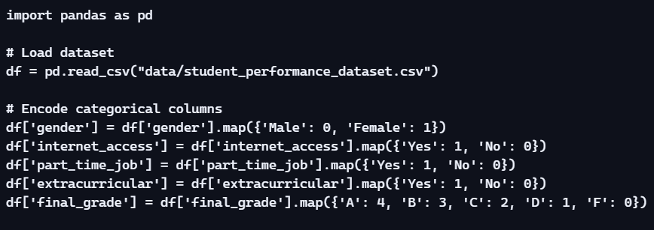

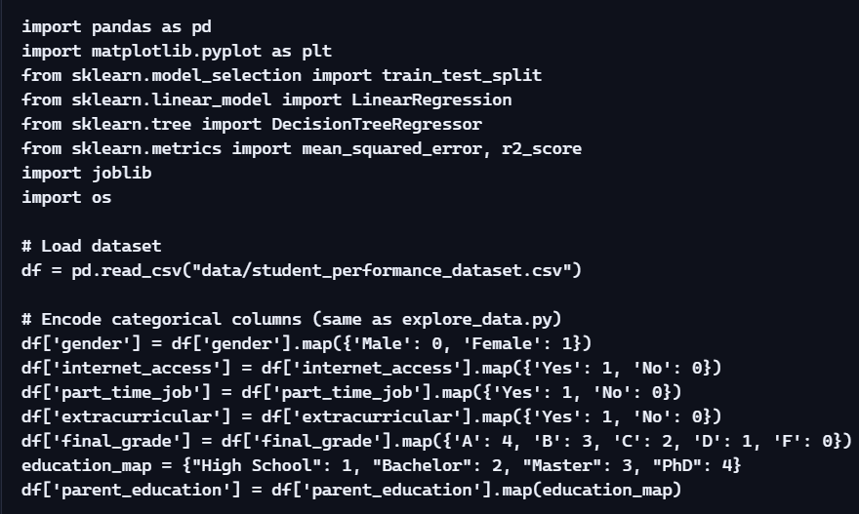
    - train_models.py — Model Training, Evaluation & Saving

